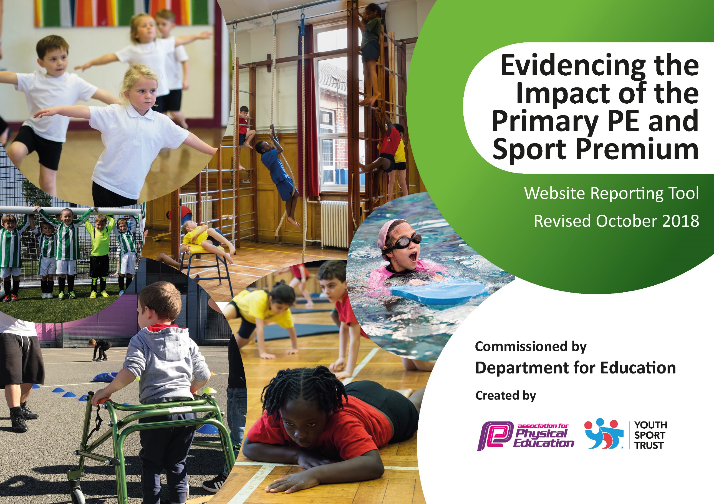
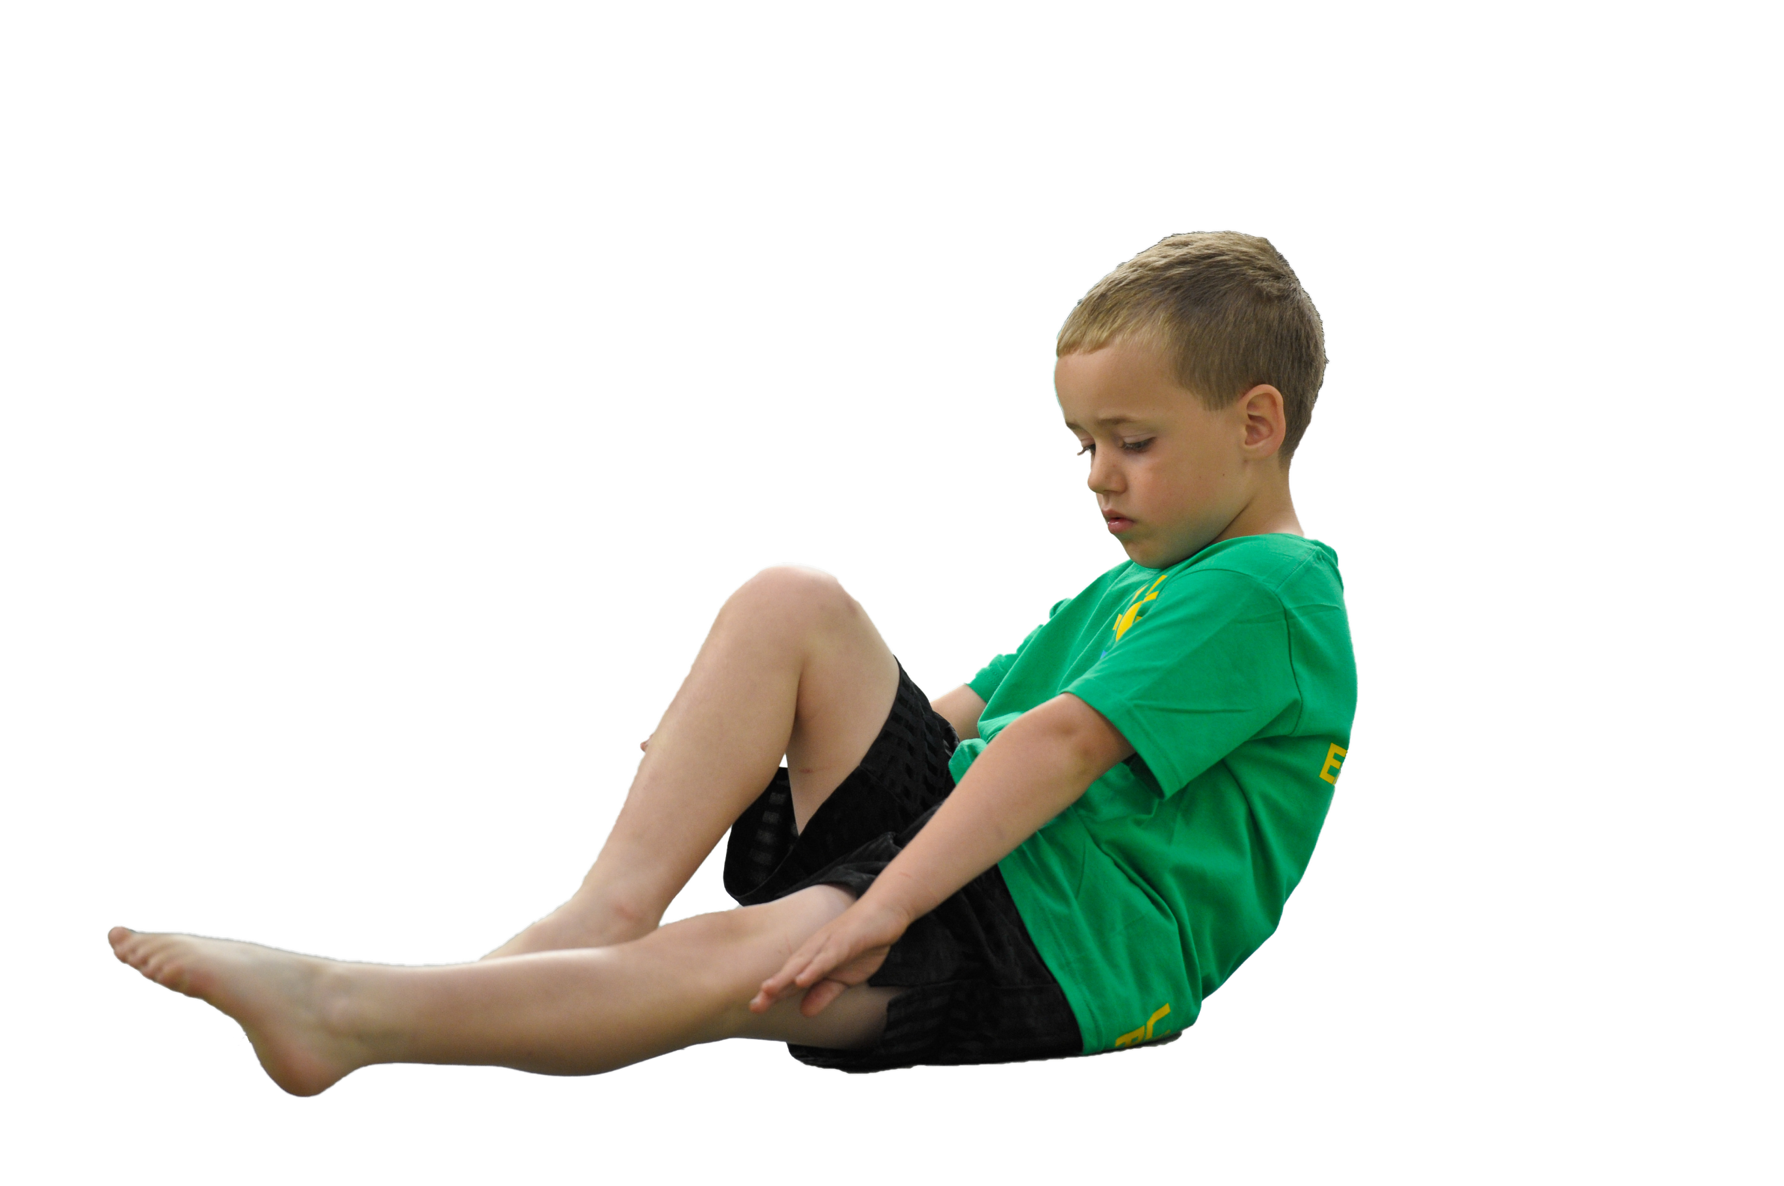
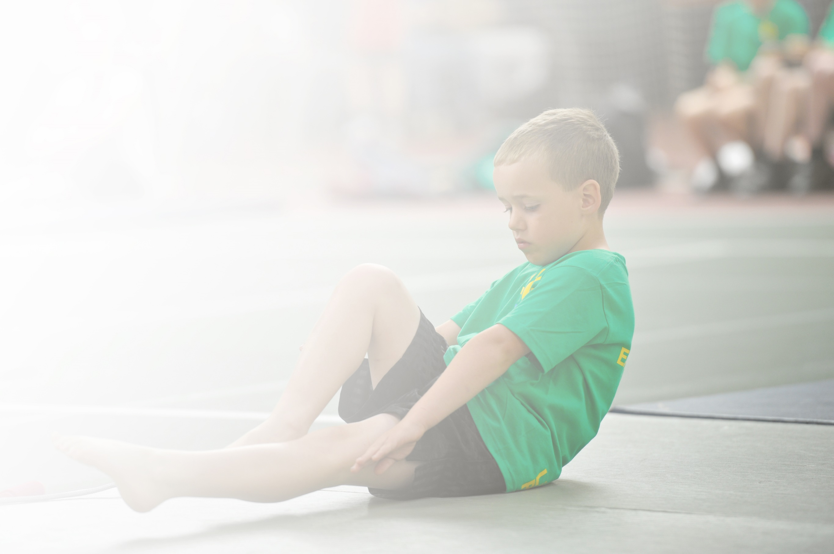
Schools must use the funding to make additional and sustainable improvements to the quality of Physical Education, Sport and Physical Activity (PESPA) they offer. This means that you should use the Primary PE and Sport Premium to:

- Develop or add to the PESPA activities that your school already offer
- Build capacity and capability within the school to ensure that improvements made now will benefit pupils joining the school in future years

Please visit gov.uk for the revised DfE guidance including the 5 key indicators across which schools should demonstrate an improvement. This document will help you to review your provision and to report
your spend. DfE encourages schools to use this template as an effective way of meeting the reporting requirements of the Primary PE and Sport Premium.

We recommend you start by reflecting on the impact of current provision and reviewing the previous
spend. Under the Ofsted Schools Inspection Framework, inspectors will assess how effectively leaders use the Primary PE and Sport Premium and measure its impact on outcomes for pupils, and how effectively governors hold them to account for this.

Schools are required to publish details of how they spend this funding as well as on the impact it has on pupils’ PE and sport participation and attainment by the end of the summer term or by 31 July 2019 at the
latest.
We recommend regularly updating the table and publishing it
on your website throughout the year, as evidence of your
ongoing review into how you are using the money to
secure maximum, sustainable impact. To see an
example of how to complete the table please
click HERE.

Support for review and reflection - considering the 5 key indicators from DfE, what development needs are a priority for your setting and your students now and why? Use the space below to reflect on previous spend, identify current need and priorities for the future.

Key achievements to date: | Areas for further improvement and baseline evidence of need:
- The children are engaged with PE throughout the day and have positive attitudes, enjoy participating and are confident to attempt a range of sports, activities and new challenges. Every class has enjoyed active playtimes with a range of equipment within their own bubbles.  - Sports, competition and healthy active lifestyles continue to have a high priority and across the year groups. Interactive competitions have supported children’s well-being and mental health to fill a void in their out of school team sports.  - The design of the new PE curriculum builds on fundamental skills and concepts throughout the year group. It gives the teachers a clear plan of what to teach and in combination with the PE scheme will ensure quality teaching.  - The children have had the opportunities to participate in competitive sports through virtual competitions. Opportunities were fewer due to COVID restrictions and lockdown.  - 75% if year 6 children can swim 25 meters. | - Implement the new curriculum design and follow up on the use of the PE scheme of work, especially with new staff. Ensure all lessons are always active and good progress is made from all children.  - Continue to seek out opportunities for competition and for local clubs to come in and give taster sessions. Encourage children to act on their interests outside of school and join new clubs, especially our vulnerable children, monitor this throughout the year.  - All year groups to carry out water safety lessons in school and all KS2 children to attend swimming, identify children who may need some extra lessons.  - KS1 children to continue to develop their fundamental skills which may have been affected during lockdown. Provide extra active sessions for this and try to plan in opportunities to practise skills within lessons.

Meeting national curriculum requirements for swimming and water safety | Please complete all of the below:
Schools can choose to use the Primary PE and Sport Premium to provide additional provision for swimming but this must be for activity over and above the national curriculum requirements. Have you used it in this way? – see above. | 45%

Action Plan and Budget Tracking
Capture your intended annual spend against the 5 key indicators. Clarify the success criteria and evidence of impact that you intend to measure to evaluate for students today and for the future.

Academic Year: 2020/21 | Total fund allocated: £17310 | Date Updated: November 2020
Key indicator 1: The engagement of all pupils in regular physical activity – Chief Medical Officer guidelines recommend that primary school children undertake at least 30 minutes of physical activity a day in school |  |  |  | Percentage of total allocation:
 |  |  |  | %
School focus with clarity on intended impact on pupils: | Actions to achieve: | Funding allocated: | Evidence and impact: | Sustainability and suggested next steps:
Engage KS1 pupils in new activities at local venues, leading to future participation and engagement.  More opportunities to be active on the playground.  Develop pupil and staff understanding  of the importance of leading a healthy and active lifestyle.  Provide additional opportunities for all pupils to be more active, more often | All classes to attend a festival highlighted 3 different activities they can become involved in.  Play Leader training for 5/6 pupils identifying leadership skills and ways in which they can engage younger pupils in physical activities on the playground  FAN (fitness and nutrition) programme. A whole day of activities for staff pupils and parents focusing on developing and leading a healthy and active lifestyle  Organise a whole school Healthy Lifestyles week in the Summer Term  Cyber Coach used to provide all pupils with additional opportunities to be active.  Purchase new equipment to support the delivery of curriculum PE, lunchtime activities, after school clubs and participation in competitions  PE Passport APP embedded across the school to support the delivery and assessment of PE and track wider participation in extra curricular activities. | Edsential PE SLA (£6500)  Edsential PE SLA (£6500)  Edsential PE SLA (£6500)  £1000  £342.50  £2000  Edsential PE SLA (£6500) | Due to COVID, the festival did not go ahead this academic year, however we hope to attend next year  The outdoor areas are being used well with different activities being organised by the class teachers to develop skills and fitness. Although year 6 couldn’t carry out the active play due to COVID, they did organise their own games in their bubbles which encouraged strategic thinking.  FAN Days, Pupil feedback (years 4, 5 and 6) showed that they felt much more motivated and positive after exercising and would use the activities they had been taught to help them manage any negative feeling or stress in their lives, especially during lockdown.  Cyber Coach, Ks1 and LKs2 used in the morning as a wake up, shake up routine to get them ready for learning. The children were more engaged on the work directly after the session and it improved stamina after lockdown.  New sports equipment has lead to more engagement at lunch and breaktime which has worked on fundamental skills, especially post lockdown. A wider varied of skills can be taught with the equipment and after school activities have been planned for next year.  The PE passport is helping to develop the assessment of children in PE and | Increase the opportunities for year 1 to take part in Edsential competitions and festivals and seek further opportunities from local clubs.  Encourage year 6 pupils to take part in active play training next year and support them in delivering this to the younger children. Keep a record of those children who are taking part so we can encourage other children who are less active.  Continue to provide FAN days for all pupils and build fitness and nutritional education into everyday PE lessons. Provide opportunities for parents to take part in FAN week.  Provide more opportunities for children to be active during the lessons, use the outdoor spaces and equipment.  Continue to build on the skills children have when using the sports equipment so that they can set up games independently during breaktime and lunchtime. Use the equipment to provide more varied after school activities.

Key indicator 2: The profile of PESSPA being raised across the school as a tool for whole school improvement |  |  |  | Percentage of total allocation:
 |  |  |  | %
School focus with clarity on intended impact on pupils: | Actions to achieve: | Funding allocated: | Evidence and impact: | Sustainability and suggested next steps:
Use Physical Activity to improve resilience, confidence and attitudes towards being active in targeted groups of pupils.  Using physical activity to help children control emotions and anxieties in daily life and build a bank of coping strategies to help them outside of school in their free time.  Engage families in regular physical activity, highlighting and promoting the benefits of being active as a whole family. | Personal Best Programme used to work with identified groups of pupils with focus on achieving individual targets in relation to self-esteem, resilience and attitudes towards being active.  Fundamentals programme to be carried out 6 week block  Engage families in regular physical activity, promoting and highlighting the benefits of being active as a whole family. | Included in Edsential PE SLA (£6500)  (£5200)  Included in Edsential PE SLA (£6500) | Personal Best Programme ran during the Summer term for 6 weeks. The children were identified for teaching staff who were lacking in confidence, below ARE or were less active than others. Pupil voice, most year 5/6 pupils said they felt more confident after the personal best programme and were more inspired to carry out exercise at home.  Feedback from Edsential Staff and analysis showed an improvement in confidence, resilience to keep trying, enjoyment and self- esteem. Following the programme 85 % of pupils said that they would keep trying when things become difficult which is an increase of 40%. 95% of the pupils felt more confident after the programme which is an increase of 55%. 100% of the pupil like to take part in physical activity.  Trained member of staff to work with selected students to work on emotional resilience and building a bank of strategies to help with anxieties. 80% if the children noted that using the physical activities and breathing techniques from these sessions helped them when they felt anxious at home . 90% of children said that they had a bank of physical activities they could use if they felt stressed or worried and would feel confident tot use them in a safe space at home or in school.  Fundamentals programme devlivered in Autumn 2, Staff selected all of F2 and particular children in year 1 who needed further support on gross and fine motor skills. Summary from the report- good progress was made across all areas. Throwing and jump were particular areas of strength. All children showed a positive attitude toward the physical activity.  Family engagement could not take place year due to COVID | Continue to provide the personal best programme for identified children. Continue to follow up the progress of these children with pupil voice and encourage them to continue with an active lifestyle in and after school.  Continue to provide this to groups of children who have been greatly affected by covid and extend the support to families to to be able to support the children at home.  Provide this programme for our current F2 children and those children in year 1 requiring some extra support with their fundamental skills.  Provide opportunities for parents to take part physical activity with their children and workshops about living a healthy lifestyle. Provide information on local club/facilities which can support whole families in being more active.
Key indicator 3: Increased confidence, knowledge and skills of all staff in teaching PE and sport |  |  |  | Percentage of total allocation:
 |  |  |  | %
School focus with clarity on intended  impact on pupils: | Actions to achieve: | Funding  allocated: | Evidence and impact: | Sustainability and suggested  next steps:
Support PE Subject Leader to ensure all opportunities available are being maximised/share good practice from other schools and develop new partnerships  Improve the quality of teaching and learning in curriculum PE | PE Subject Leader Support Programme includes a termly visit from PE Advisor to support and develop the current and future provision  Regular Subject Leader Network Events to share ideas and make links with colleagues  Programme of learning walk and observations to monitor the current teaching and learning in curriculum PE  PE Curriculum Support Training for identified members of teaching staff  Clubs and taster sessions- Sale sharks, local football clubs- Victoria Colt, boxing and tennis club  Judo sessions to be completed by year 5 and year 6 in the Spring/Summer term (Covid dependent)  Pedometer step up challenge to be completed with year 3, 5 and 6 | Edsential PE SLA (£6500)  £70  Edsential PE SLA (£6500)  Edsential PE SLA (£6500)  £250  £940 | PE subject leader worked with PE advisor to redesign the new PE Curriculum. A long-term Plan was created based on the needs of the children in the year groups and the context of the local area. Clear Intent, Implication and Impact which is supporting a spiral curriculum of building on fundamental skills, fitness and strategic thinking  Staff CPD did not take place this year due to COVID  Staff are now all using the Edsential scheme of work to structure their lessons and ensure the focus is on making progress through the key themes. Learning walks could not take place due to COVID  Wheelchair rugby offered to year 6, one child joined a rugby club following this and child directed learning took place during lunchtimes with tag rugby. Coach from local football team came into train with year 3 and 4. Multiple children joined football clubs following this.  Year 5 and 6 completed the judo sessions and felt more confident in themselves, they enjoyed the sessions and wanted to join a club out of school.  Class 3/4and 5/ 6 had the opportunity to use activity trackers for a week, results showed that children were averaging 10,00 steps across the school day with lunchtimes and breaktimes being particularly active. Some children were asking parents to do additional activities after school | Carl Sutton from Edsential to continue his valuable support for subject leader for PE, to enhance own CPD for leading the subject and other staffs CPD to deliver a variety of provision. Subject leader to attend courses and training.  Teachers to continue delivering sessions which they have received support with.  Development of monitoring and observations with GF and Carl Sutton with a focus to enhance and develop provision and staff skills.  Seek out further opportunities for taster sessions from clubs in the local area and follow up the impact of these on the take up outside of school.  Continue to provide Judo sessions for year 5 and 6. Provide information on local judo clubs and monitor uptake outside of school. Carry out a pupil voice survey before and after the sessions to guage the full impact on resilience, motivation, confidence and self-esteem.  Continue to provide the pedometer step up challenge as it had a huge impact on the children in year 5 who have bought their own pedometers and set their own challenges to have an active day.

Key indicator 4: Broader experience of a range of sports and activities offered to all pupils |  |  |  | Percentage of total allocation:
 |  |  |  | %
School focus with clarity on intended  impact on pupils: | Actions to achieve: | Funding  allocated: | Evidence and impact: | Sustainability and suggested  next steps:
Provide a wide range of new opportunities for all pupils to be active in after school activities.  At least 65% of the pupils in the school to engage in some after school activity. | After School Sports Clubs promoted and participation linked to competitive opportunities.  Use PE Passport to identify trends and gaps in provision and target groups of pupils who are inactive. | Included in Edsential PE SLA (£6500)  £1000  (additional after school activities) | Limited extracurricular clubs could take place due to COVID, however there was a good uptake with year 2 for a breakfast gymnastics club. The children’s attendance remained good throughout the 6 weeks and all children engaged actively within the sessions. As a result, we were unable to utilise the PE Passport to its full potential. | School to continue developing opportunities for extra-curricular clubs/sports/ activities. Promote clubs through newsletter, worship, Twitter, website – will be restricted if we go back into lockdown.  Target year groups who have shown a willingness to attend after school clubs previously – this will start later in the academic year
Key indicator 5: Increased participation in competitive sport |  |  |  | Percentage of total allocation:
 |  |  |  | %
School focus with clarity on intended  impact on pupils: | Actions to achieve: | Funding  allocated: | Evidence and impact: | Sustainability and suggested  next steps:
Develop self esteem and confidence through regular participation in school competitions.  Engage all pupils in regular intra school competitions  Engage at least 50% of pupils in inter school competitions | Fortnightly virtual competitions for classes vis Edsential and South Wirral  Use of ‘house teams’ or classes to encourage participation in intra competitions (developed by the school council and delivered by Play Leaders when able)  Promote and celebrate competitions and events across the school to develop a positive whole school approach towards representing the school.  Transport for Competitions and Events | Edsential PE SLA (£6500) | 40% of children in UKS2 regularly took part in interschool competitions virtually which boosted their self esteem and increased activity during break and lunchtimes.  Due to Covid the house system has not been used this year as we have been unable to mix bubbles.  Due to Covid, there have been limited opportunities for children to engage in competitions and events. Those that did take part in the virtual competitions enjoyed taking part and it boosted their time spent being activity but the virtual aspect made it difficult for younger members to grasp.  Was not required due to Covid. | To have a positive whole school approach towards competitions by providing opportunities to attend inter-school and inter house competitions with the hope of children finding a new sport or activity that they enjoy to continue during their free time inside or outside of school.  Competitions that the children are involved with are promoted/ celebrated and recognised in worships.  Increase opportunities for the children to participate as 'houseteams' through intra school competitions.  School Council and Play leaders to develop intra house competitions.

Key indicator 6: Additional Swimming- Y3,4,5 and 6
School focus with clarity on intended  impact on pupils: | Actions to achieve: | Funding  allocated: | Evidence and impact: | Sustainability and suggested  next steps:
At least 60% of Y6 to meet national curriculum requirement or better.  At least 40% of Y5 to meet national curriculum requirement or better.  At least 20% of Y4 to meet national curriculum requirement or better.  At least 10% of Y3 to meet national curriculum requirement or better | Attend either 1 week - 1hour block of swimming sessions or 2 week 1/2 hr block. |  | 45% of Year 6 children met the expected national curriculum requirement for swimming at the end of the academic year.  Other year groups did not swim  Achievement certificates are awarded to the children as part of Celebration Worship with photographs taken for website/Twitter  Feedback/Discussion and assessments are completed with staff and swimming instructors .  All current KS2 trained L1 swimming Instructors | Identification of y6 (Sept 21) children who could require additional swimming sessions to achieve NC requirements.  Have a greater focus on water safety in school.  Identification of any new staff who would need to complete Swimming L1 course.

